

Year 11 EARTH AND ENVIRONMENTAL SCIENCE

UNIT 1, 2020

**Test 1- Food chains, food webs and the transfer of energy**

Student Name: ______________________________

Assessment Date:

Total Weighting: 10%

I acknowledge that all the information contained in this task is my own work and not taken from other sources. If other sources have been used they have been acknowledged in my references.

____________________________________

(Student Signature)

**Part A: Multiple-choice (10 marks)**

This section has 14 questions. Answer all questions on the multiple-choice answer sheet.

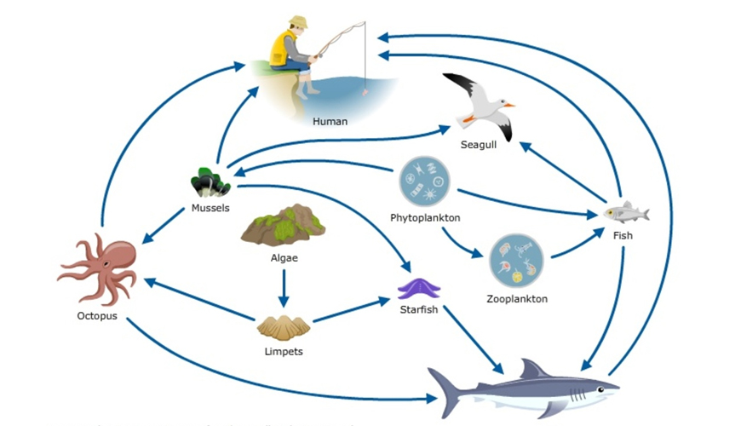The next three questions refer to the diagram below

1. Which organisms are the producers?
   1. Zooplankton and phytoplankton
   2. Algae and phytoplankton
   3. Algae and limpets
   4. Algae and mussels
2. Which organism is the apex predator?

a) Shark

b) Human

c) Seagull

d) Octopus

1. Based on the diagram above can you identify the trophic level that the octopus belongs to?
   1. Primary producer
   2. Secondary consumer
   3. Primary consumer
   4. Tertiary consumer
2. Which trophic level does seagrass belong to?
3. Primary consumer
4. Primary decomposer
5. Secondary consumer
6. Primary producer

5. Plants are found at the beginning of food chains because they

a) cannot move around to obtain food.

b) are the most common food source available.

c) do not have any structures for biting and chewing.

d) are able to convert light energy into food.

6. Which is the correct definition of a **decomposer?**

a) An animal that is able to produce its own food source

b) A waste organism

c) An organism that is able to find its own food

d) An organism that consumes waste products and dead matter

7. Which of the below organisms would be considered an apex predator consumer? **(there may be more than one answer**)

a) small shark

b) large fish

c) humpback whale

d) Orca whale

8. Which of the biomass pyramids represents a stable ecosystem?

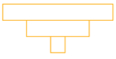

a) b)

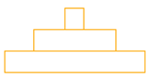

c) d)

9. Which of the following is correct

a) producers have the most biomass and apex predators have the least biomass

b) producers have the least biomass and apex predators have the most biomass

c) secondary consumers have the least biomass and producers have the most biomass

d) primary consumers have the most biomass and producers have the least biomass

10. State which organisms are found in the second trophic level

a) Second order consumers

b) Herbivores

c) Third order consumers

d) Producers

**Short Answer Section (27 marks)**

11. Using the following formula **biomass (g/m2) = number x mass (g)**

a) Complete the following table **(4 marks)**

|  |  |  |  |
| --- | --- | --- | --- |
| Organism | Number | Organism mass (g) | Biomass (g/m2) |
| Eucalyptus tree | 1 | 10000 |  |
| Kookaburra | 1 | 800 |  |
| termite | 1100 | 8 |  |
| lizards | 28 | 70 |  |

b) draw an appropriate biomass period in the space below **(2 marks)**

c) Can you label the biomass pyramid with the organisms that belong **(4 marks)**

d) Explain why biomass tends to decrease as you go up trophic levels **(3 marks)**

___________________________________________________________________________

___________________________________________________________________________ _________________________________________________________________________________________________________________________________________________________________________________________________________________________________

16. A team of biologists spent time on a research station in Antarctica. Their job was to study feeding relationships amongst species. Whilst there they noticed the following:

*‘Squid was observed eating krill and phytoplankton. They compete for the food source of krill with penguins, fish, leopard seals, other birds, baleen whales and other seals. Phytoplankton was observed as the main food source for zooplankton and Krill. Consumers of zooplankton include squid (as mentioned), fish and krill. Squid has been observed being eaten by elephant seals, penguins and fish. Penguins are also a consumer of fish with their main predators leopard seals and small toothed whales. Leopard seals are known to consume other birds, krill and fish. Other seals and elephant seals are solely consumed by smaller toothed whales. Smaller toothed whales consume larger organisms such as penguins, squid, and baleen whales. Baleen whales only food source is krill, whereas sperm whales only food source is squid.*

a) Use the information in the paragraph above to construct a food web showing all the feeding relationships. **(6 marks)**

b) What do the arrows in the food web represent? (1 mark)

__________________________________________________________________________________________________________________________________________________

c) Identify **two (2)** primary consumers in the food web. (2 marks)

_________________________________________________________________________________________________________________________________________________

d) Identify the apex predator in the food web diagram (1 mark)

__________________________________________________________________________________________________________________________________________________

e) Explain what would occur if squid is overfished by humans (4 marks)

________________________________________________________________________________________________________________________________________________________________________________________________________________________________________________________________________________________________________________________________________________________________________________________________________________________________________________________________________________________________________________________________________________________________________________________________________